Excel & Power BI Mini Project Documentation

Project Title

Sales & Revenue Analysis using Excel and Power BI

1. Introduction
This project presents a comprehensive analysis of sales and revenue data using Microsoft Excel and Power BI. The dataset was first explored and prepared in Excel, followed by advanced modelling and visualization in Power BI. The objective was to understand sales performance, revenue trends, and the effect of discounts on overall business outcomes. By combining Excel-based preprocessing with Power BI’s analytical and visualization capabilities, the project demonstrates an end-to-end data analytics workflow.
The Excel sheet contains structured transactional sales data, which was validated, cleaned, and enhanced with calculated fields. The Power BI file builds on this prepared dataset to create measures, apply filters, and generate interactive visuals that support data-driven decision-making.

2. Data Exploration

2.1 Data Collection
The dataset used in this project was collected from Kaggle on January 18, 2025. It represents historical sales transaction records designed for analytical and learning purposes. The data was downloaded in Excel format and served as the primary data source for both Excel analysis and Power BI reporting.

2.2 Features Identified for Analysis
Key features identified and used for analysis include:
Feature Name | Description
Order Date | Date of the sales transaction
Customer Name | Name of the customer
Product / Category | Product name or category sold
Quantity | Number of units sold
Price per Unit | Selling price per unit
Discount Applied | Boolean flag (True/False) indicating discount
Sales Amount / Revenue | Total revenue generated per transaction
These features were selected as they directly influence revenue, sales volume, and performance evaluation.

2.3 Report Screenshots (Non-Dashboard)
During exploration, multiple Power BI report pages were created before finalizing the dashboard. These include:
- Table visuals showing raw and aggregated sales data
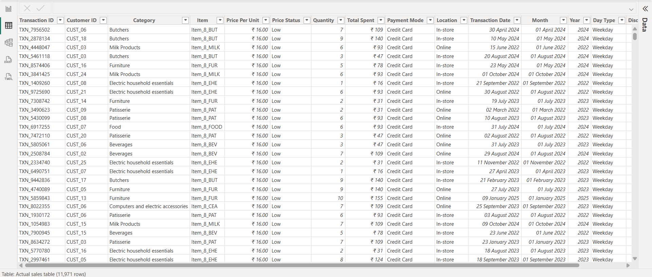
- Card visuals for individual KPIs such as total revenue and sales quantity
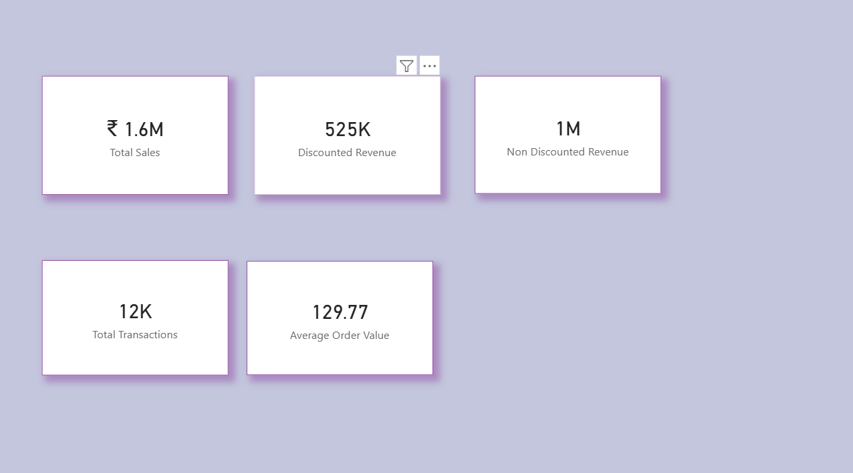

Simple charts to validate trends before dashboard design
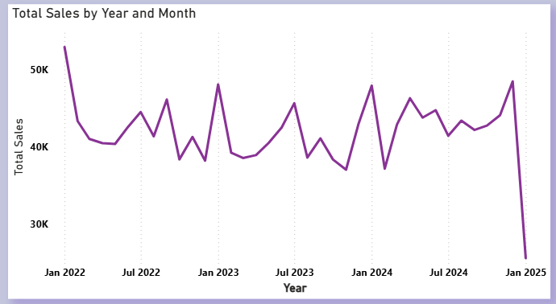
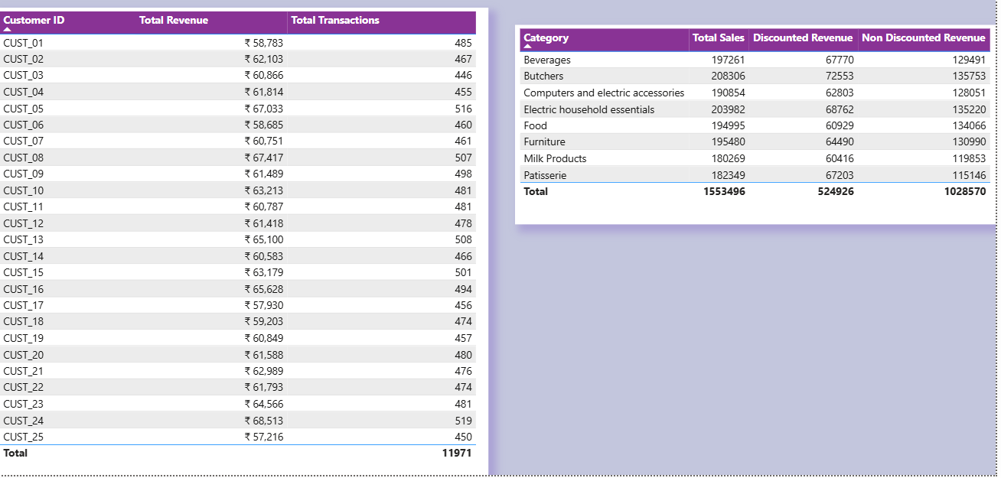

2.4 Visualizations Generated Using Power BI Dashboard
The following visualizations were generated during exploration and analysis:
- KPI Cards (Total Revenue, Discounted Revenue, Total Quantity)
- Bar and Column Charts (Revenue by Product / Category)
- Line Charts (Sales and Revenue Trend over Time)
- Comparative charts for Discounted vs Non-Discounted Sales
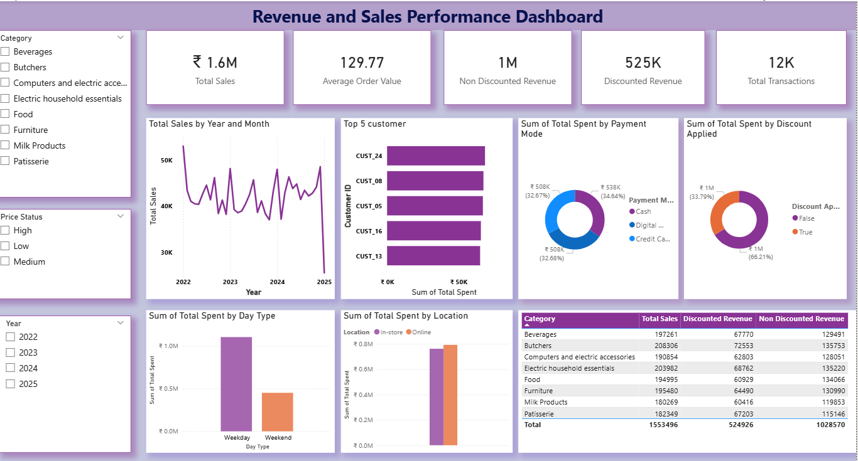

3. Methods

3.1 Pre-processing Techniques Used

a. Loading the Dataset
- The Kaggle dataset was initially loaded into Microsoft Excel.
- After preprocessing, the cleaned Excel file was imported into Power BI using Power Query.

b. Understanding the Dataset
- Reviewed column names, data types, and value ranges
- Identified numerical and categorical variables
- Checked for missing, duplicate, and inconsistent values

c. Dataset Cleaning
Based on analysis of the Excel and Power BI files, the following cleaning steps were applied:
- Removed blank and irrelevant rows
- Corrected data types (dates, numeric fields)
- Standardized text fields such as product and category names
- Created calculated columns such as:
  - Price per Unit
  - Total Sales / Revenue
- Validated Discount Applied values (True/False)
Excel formulas such as IF, arithmetic calculations, and lookup logic were used where required to ensure data consistency before modelling.

4. Modelling

Data modelling was performed in Power BI to convert cleaned transactional data into meaningful aggregated insights. In addition to the base sales table, Group By tables were created using Power Query to summarize data at different analytical levels.

4.1 Group By Tables

Based on the Power BI file, the following Group By operations were applied:
- Product-level aggregation: Grouped data by Product / Category to calculate total revenue, total quantity sold, and discounted revenue.
- Date-level aggregation: Grouped by Order Date (or derived date fields) to analyze sales and revenue trends over time.
- Discount-based grouping: Grouped by Discount Applied (True/False) to compare discounted versus non-discounted sales performance.

These Group By tables reduced row-level complexity and improved performance while enabling clearer analytical comparisons.

4.2 Measures and Calculations
- Created DAX measures on top of both base and grouped tables, including:
  - Total Revenue
  - Discounted Revenue
  - Total Sales Quantity
- Applied proper aggregation logic to ensure accurate calculations across slicers and filters.

4.3 Filter Context and Relationships
- Ensured grouped tables aligned correctly with the main dataset
- Enabled slicers (Date, Category, Discount Applied) to interact seamlessly with all visuals
- Verified that filter context propagated correctly across grouped summaries
5. Results

5.1 Key Findings
Parameter | Result / Insight
Total Revenue | Identified overall revenue generated across all transactions
Discounted Revenue | Discounts contribute significantly to sales volume but reduce per-unit revenue
Top Products / Categories | Certain products and categories consistently outperform others
Sales Trend | Revenue shows clear variation across time periods
Discount Impact | Discounted sales increase quantity sold but lower net revenue margins

5.2 Analytical Observations
- Products with discounts tend to sell in higher quantities
- Non-discounted products contribute more to overall profitability
- Seasonal or date-based trends affect sales performance
- Interactive slicers enable quick comparison across categories and time periods
The Power BI dashboard consolidates these findings into a single interactive view for stakeholders.

6. Conclusion
This project successfully demonstrates the use of Excel and Power BI for structured data analysis and visualization. Starting from a Kaggle dataset, the data was explored, cleaned, modelled, and transformed into meaningful insights. Excel played a critical role in preprocessing and validation, while Power BI enabled advanced modelling and interactive reporting.
The results highlight key sales drivers, the impact of discounts, and product-level performance trends. Overall, the project showcases strong analytical thinking, data preparation skills, and business intelligence capabilities suitable for real-world data analyst roles.

